Media Release– draft not for release

Victorian Better Apartments Design Guidelines loving the rain

Congratulations to the Victorian Planning Minister for the integrated water objectives in the new Apartment Design Guidelines. Victorians need better management of the precious rain that falls on our cities and the Guidelines are a step in the right direction.
More rain falls on Melbourne each year than we use from our dams and desalination plants. Most of the rain becomes stormwater that is expensive to manage. Incorporating rainwater, stormwater and recycled water sources into new apartment developments for toilets, laundry and gardens better manages both rainwater and stormwater, ultimately improving the water quality in our urban waterways.
“Based on Professor PJ Coombe’s research on urban system water flows, lot scale rainwater harvesting has a proven threefold benefit: it reduces household expenditure on water, it reduces the costs of water infrastructure across the urban system and it reduces stormwater management costs.”
Stuart Heldon, Independent Water Council
“CASBE applauds the inclusion of rainwater harvesting and re-use in the Victorian Apartment Design Standards. Alternative sources of water are an important part of a holistic approach to lower impact development”.
Natasha Palich, Executive Officer Council Alliance for a Sustainable Built Environment.
Rainwater harvesting is the third largest source of water in Australia after surface water (dams) and groundwater, and one in four households in Australia have a rainwater tank. Rainwater harvesting is the first element of an integrated water management system.
Rainwater Harvesting Association of Australia –Stuart Heldon 0418 216 878
Council Alliance for a Sustainable Built Environment –Natasha Palich 0425 723 735
Ends

Company profile – Independent Water Council
The Independent Water Council is a not for profit alliance of water industry stakeholders including the Association of Rotational Moulders Australasia (The Water Tank Group), Irrigation Australia, Rainwater Harvesting Association of Australia, Australian Water Association, Stormwater Australia and the Australian Wastewater Treatment Association.

The objective of the Council is to market the importance of independent water sources, appropriate resource management & policy development.

Independent Water Council website: www.independentwatercouncil.org
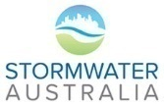
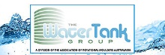
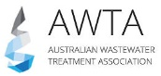
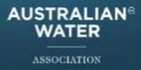
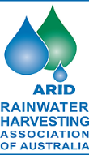

The Council Alliance for a Sustainable Built Environment (CASBE) is an association of Victorian councils committed to the creation of a sustainable built environment within and beyond their municipalities.
CASBE councils focus on maximising the benefits of integrating Ecological Sustainable Development (ESD) in planning policy.
Our work supports our community shift towards a sustainable built environment.
See us in action here.
CASBE is supported by the Municipal Association of Victoria
www.casbe.org.au

