Draft Rainwater Harvesting Position Paper
Rainwater Harvesting Association of Australia,
Based on the research of Professor PJ Coombes
July 2017
What is Rainwater Harvesting and why is it important?
Rainwater Harvesting is rainwater captured from a roof into a container. Rainwater collected from the ground usually has a higher level of contaminants requiring more treatment and making that water more difficult to store. Rainwater collected from above the ground is generally referred to as stormwater.
A broader definition of rainwater harvesting used by the American Rainwater Catchment Systems Association (ARCSA) also includes ‘passive rainwater harvesting’ which is the collection and infiltration of rainwater into the ground for beneficial uses without intermediate storage in a tank. Passive rainwater harvesting may be collected for infiltration to increase soil moisture levels or groundwater supplies or guided to provide local irrigation to trees or feed a pond or small dam. In Australian terms, a typical example would be a raingarden.
Correctly installed Rainwater Harvesting systems develop a natural treatment train that addresses many of the potential contamination issues that may be associated with a roof catchment. This is an important reason why rainwater harvesting is so widely used in Australia and rainwater users remain healthy.
Using rainwater harvesting to reduce potable water demands has a benefit in reducing future water infrastructure costs, a double benefit in improving household welfare and a triple benefit in reducing stormwater infrastructure cost and risks. This is why rainwater harvesting is considered an integrated water solution, one piece of infrastructure has multiple benefits at multiple scales.
The Rainwater Harvesting Association of Australia, through Professor Peter Coombes from UWCS and his colleagues, have extensively monitored the inputs and outputs of residential rainwater harvesting systems. This evidence provides a perspective that is independent of the traditional water industry and a centralised water distribution paradigm. The research shows that rainwater harvesting reduces the costs of the entire urban water system. Combining rainwater harvesting systems with mains water supply would save Victorians $6B and South East Queensland $3.5B by 2050. The estimated cumulative savings in NSW from the implementation of rainwater harvesting and water efficient appliances under the BASIX program is over $4B since 2004.
Figure 1 shows the relative operating costs of major water utilities based on the BOM National Performance Reporting data. NSW is the only state to effectively implement rainwater harvesting from 2004.
Figure 1. Major Water Utility operating costs per property
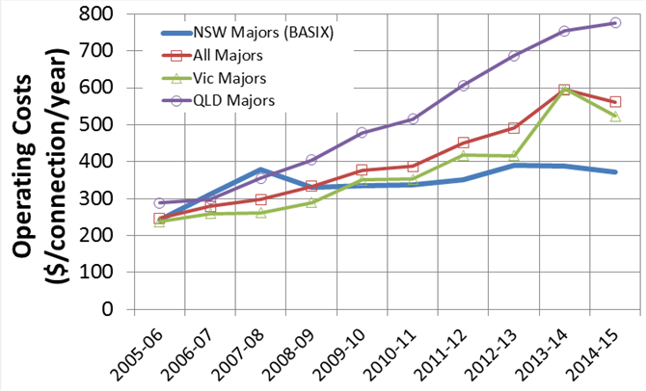
How important is Rainwater Harvesting?
Rainwater Harvesting is the third largest source of water in Australia, after surface water (dams) and groundwater. Rainwater Harvesting provides an independent estimate of 274 billion litres annually. According to the ABS one in four, or 26% of Australian houses have a rainwater tank. The ABS estimate rainwater provides 177 billion litres, or 9% of residential water in Australia worth $540 million. Outside of urban areas rainwater provides 63% of residential water or 109 billion litres. Groundwater provided an estimated 385 billion litres, desalination only 144 billion litres and surface water 12 trillion litres in 2014/15.
Rainwater harvesting is the first and most efficient element of an integrated water management system. Because rainwater falls on roofs it is a local supply that can be collected where it is needed. Because rainwater is usually high quality and there is a natural treatment train in rainwater harvesting systems, rainwater can meet significant local water demand until it runs out. Capturing rainwater reduces the negative impacts of urban water on natural catchments. Rainwater harvesting is used more efficiently when it is combined with another source of water to provide water security without having to invest in very large collection systems and rainwater tanks.
Rainwater harvesting is not usually a water source for water utilities and does not attract a supply charge. Rainwater Harvesting is therefore not generally measured or analysed and its strategic and economic significance is not understood. The ABS in 2014/15 estimated rainwater harvesting provided residential water supplies of 171 billion litres worth over $540 million annually across Australia⁴. The RHAA research indicates this is an under-estimation. Coombes estimated savings from rainwater harvesting and water efficient appliances in Sydney alone of 90 billion litres annually, equivalent to the entire capacity of the Sydney $1.8B desalination plant.

Figure 2 Estimated rainwater harvesting and water efficient appliances annual savings
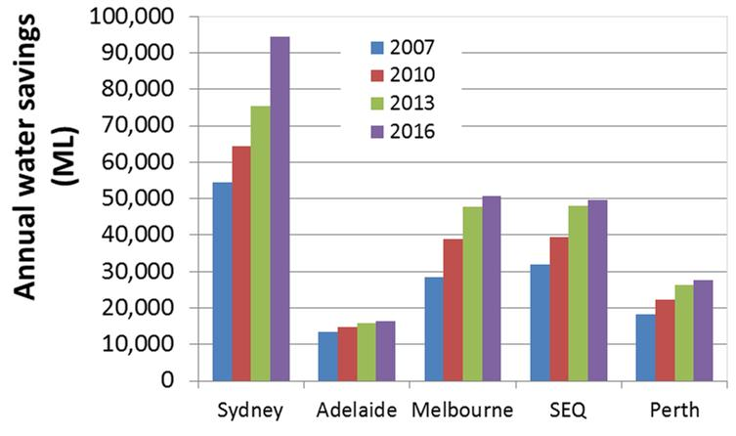
Rainwater Harvesting is the most accessible source of water in Australia. All urban areas continue to enjoy rainfall even in a drought, however, rainwater harvesting continues to provide water long after natural catchments become too dry for stream runoff.(See Figure 3). Desalinated water is not reliant on climate but is heavily reliant on a reliable electricity network, a water distribution system and high levels of public expenditure. Rainwater harvesting has little or no need for those systems. Very significant peri-urban development throughout Australia over the last two decades has occurred without significant expansion of the mains water supply system and relies almost entirely on rainwater harvesting.
Figure 3. Rainwater harvesting vs dam catchment effectiveness
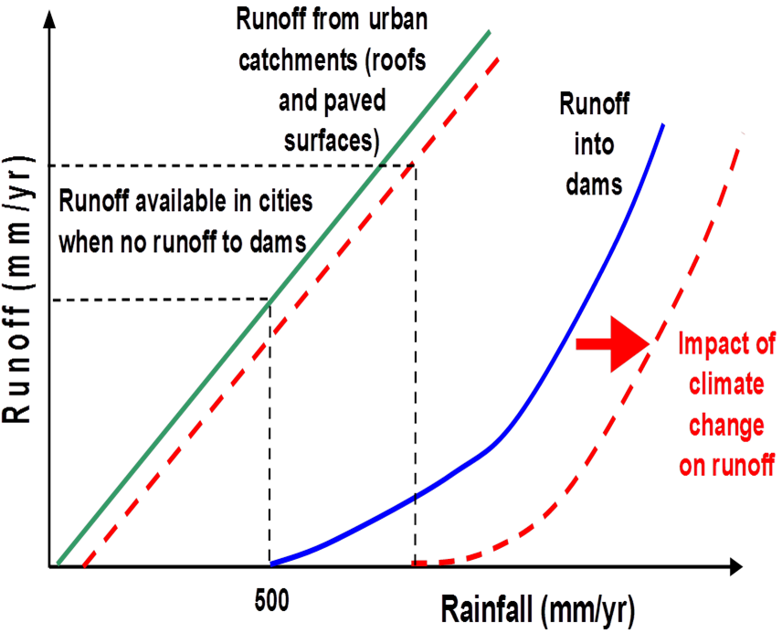

How does Rainwater Harvesting work?
Rainwater Harvesting is a system with interacting elements including rain, roof and collection, tank, pump and rainwater uses. Understanding Rainwater Harvesting requires looking at the whole system and understanding the water balance, the relationship between rainfall coming in and water being used. Regular small rain events are very significant for rainwater harvesting systems, even in dry periods most capital cities experience regular rain events every week or two. Using efficient water use appliances (such as front loading clothes washers, low flow showers and low flush toilets) within the house will reduce the capital and operating costs of the system. The behaviour of the residents will influence the design and operation of a residential rainwater harvesting system¹¹. Unlike rural systems urban rainwater tanks should be empty as much as possible, this means the yield is being maximised and the tank is ready for the next rainfall event. Mains water systems or other sources can often provide water security more efficiently than large rainwater tanks. Collecting systems data is vital to understanding rainwater harvesting because many aspects are counter intuitive at first glance. For example, the greatest determinant of rainwater yield is the number of appliances connected to the rainwater tank, greater than the size of the tank or even the size of the roof.
The risk of becoming ill from rainwater harvested water is low. Two million Australians rely entirely on rainwater and there is no evidence of widespread health impacts. One of the larger studies carried out in Australia showed that children who relied entirely on rainwater harvesting were no more likely to become ill than those who relied on potable water. Enhealth Australia states ‘In most areas of Australia, the risk of illness arising from consumption is low, providing it is visually clear, has little taste or smell and, importantly, the storage and collection of rainwater is via a well-maintained tank and roof catchment system.’ Enhealth notes that treated potable water has an even lower risk and should be used for drinking where it is available. Rainwater can be tested against the Australian Water Drinking Guidelines to assess local conditions. Urban Water Cycle Solutions and the RHAA have developed guidelines for a well-designed rainwater harvesting and treatment residential system with advice on a maintenance regime. Rainwater treatment systems should be looked at closely to ensure that additional costs have proven health benefits.
Rainwater Harvesting is not expensive. A 5000-litre residential tank with pump and plumbing can easily be installed for $3000³. Coombes research indicates that annual savings of 90kl each year can be achieved from rainwater harvesting and water efficient appliances³.
Urban areas create excess stormwater because they are dominated by impervious surfaces which create large amounts of runoff. This excess runoff leads to dangerous flooding and environmentally damage by reducing water quality in the natural environment. A rainwater tank reduces the peak, volume and level of contaminants of urban stormwater. One rainwater tank has a negligible impact however one rainwater tank on every building has a cumulative impact of billions of litres for urban stormwater.
What is the future of Rainwater Harvesting?
Rainwater Harvesting combined with access to mains water is a cost-efficient supply of water in Australia with savings to householders and downstream stormwater benefits¹³. The combination of rainwater harvesting and mains water allows a small rainwater tank to be installed which reduces the peak demand and overall demand for mains water reducing future demand for water infrastructure at every scale. When the rainwater tank runs dry mains water provides water security. The economic efficiencies are remarkable. Combining rainwater harvesting systems with mains water supply would save Victorians $6B² and South East Queensland $3.5B³ by 2050. The estimated cumulative savings in NSW from the implementation of rainwater harvesting and water efficient appliances under the BASIX program is over $4B since 2004⁵. Recent research indicates that traditional central distribution water management systems are experiencing rapidly increasing marginal costs and decreasing efficiency of supply⁵. Alternative supply paradigms such as rainwater harvesting are competitive in an urban as well as rural context. Rainwater harvesting will be amajor water policy issue in Australia in the 21st century.

ARCSA (2015) Rainwater Harvesting Manual. Arizona
Bonacci Water (2011) Living Melbourne, Living Victoria Greater Melbourne Systems Model – Modelling in support of Living Victoria Ministerial Advisory Council
Coombes P.J., Smit M., and MacDonald G., (2016), Resolving boundary conditions in economic analysis of distributed solutions for water cycle management. Australian Journal of Water Resources, Vol 20, 11-29.
Coombes and Smit (2017), Greater Melbourne Alternative Water Plan
Peter Coombes, based on purchased ABS data, 2016
ABS (2013), Environmental Issues Water Use and Conservation
ABS (2016), Water Account Australia 2014-15
Coombes and Smit (2017), Greater Melbourne Alternative Water Plan
Coombes P. J., and Barry M. E., (2008), The relative efficiency of water supply catchments and rainwater tanks in cities subject to variable climate and the potential for climate change, Australian Journal of Water Resources, 12 85-100
Independent Water Council (2017), Consultation Paper
UWCS and RHAA (2017) Design Specification for Residential Rainwater Harvesting
Peter Coombes (2011) Insights into Water Use Behaviour during the SEQ drought. Office of the Auditor General
ABS (2013), Environmental Issues Water Use and Conservation 2013 Table 3
JS Heyworth, G Glonek, EJ Maynard, PA Baghurst and J Finlay-Jones 2006 Consumption of untreated tank rainwater and gastroenteritis among young children in South Australia, Int. J. Epidemiol. Advance Access published May 24, 2006
http://www.health.gov.au/internet/main/publishing.nsf/content/0D71DB86E9DA7CF1CA257BF0001CBF2F/$File/enhealth-raintank.pdf on 21/7/2017
Coombes P. J., Smit M., Byrne J., and Walsh C., (2016) Stormwater, waterway benefits and water resources benefits of water conservation measures for Australian cities. HWRS 2016, Engineers Australia, Queenstown, New Zealand.

